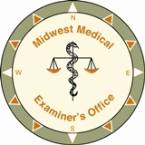
Midwest Medical Examiner’s Office
Accredited by
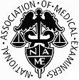
14341 Rhinestone Street NW, Ramsey, MN 55303

Phone: 763-323-6400 Fax: 763-323-6479

A. Quinn Strobl M.D. Chief Medical Examiner

Anne Bracey M.D. Michael Madsen M.D.

Principles for communicating with family during medicolegal death investigations

◊ We will make a good faith effort to notify the family of the decedent as soon as possible after death has occurred.

◊ We will provide family with information explaining the next steps after a death that comes under the jurisdiction of the medical examiner, including contact information for the Midwest Medical Examiner’s Office, and respond in a timely manner to questions from family throughout the death investigation process.

◊ We will display sensitivity and respect for cultural, religious and individual beliefs regarding death and autopsy.

Serving multiple counties in Minnesota and Wisconsin

