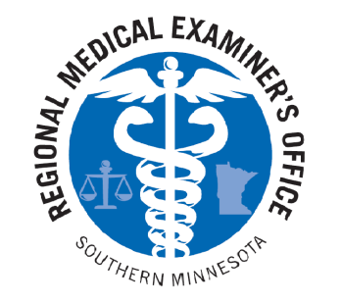
Southern Minnesota Regional Medical Examiner’s Office
Certificate of Religious Belief

Pursuant to Section 390.11, Subd. 2b of the Government Code of the State of Minnesota, I hereby execute this Certificate of Religious Belief:
Any autopsy of my family member’s body is a violation of their religious beliefs. Any procedure which allows the postmortem deterioration of their body is a violation of their religious beliefs. I will assume responsibility for the lawful disposition of the body of the deceased. I understand that the manner of death may not be classified.

Decedent name:___________________________________________________________________
Date of birth:___________________
Religious affiliation:________________________________________________________________
Basis for objection to autopsy:________________________________________________________
Legal next of kin:___________________________________________________________________
Relationship:______________________________________________________________________
Signature:_________________________________________________________________________
Date:__________________________
Subscribed and affirmed before me in the county of _____________________, State of Minnesota, this ___________day of ____________, 20____.

_______________________________
(Notary’s official signature)

_______________________________
(Commission Expiration)

Notary
Seal

